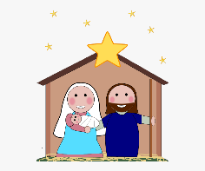


This term we will be learning
Festivals

Wrens Class 2024: Autumn 2 term 2

The Arts Singing Divali and Christmas songs. Responding to and exploring musical sounds. Sculpting clay diva lamps. Firework printing. Making Christmas decorations
Language and Communication
Talking, listening and responding to each other

Learning nursery rhymes, poems and stories.

Using talk to organise our thinking, explain our ideas and help work out problems

Physical Development
Moving fluently in different ways with increasing control

Learning to put on and take off hats, gloves, coats, shoes, wellies and slippers independently

Forming the letters we have learnt correctly.

Using scissors and tools with increasing accuracy

Maths
Singing number songs
Counting and comparing quantities accurately
Exploring number bonds
Solving problems
Exploring and comparing simple 2D shapes

Understanding the world
Keeping safe at night and Bonfire Night
Celebrating Divali, Hannukah and Christmas
Investigating freezing melting and rain
Cooking Coconut Barfi, Christmas treats

Literacy
Using letter sounds we have learnt to read and spell words.
Reading and writing simple captions and sentences.
Enjoying and learning from stories; Rama and Sita (The Divali story), Sammy spider’s Hanukkah, The Nativity story.
Personal, Social and Emotional Development
Making new friends, sharing resources
Discussing our different experiences and feelings.
Sharing our Christmas
traditions.



