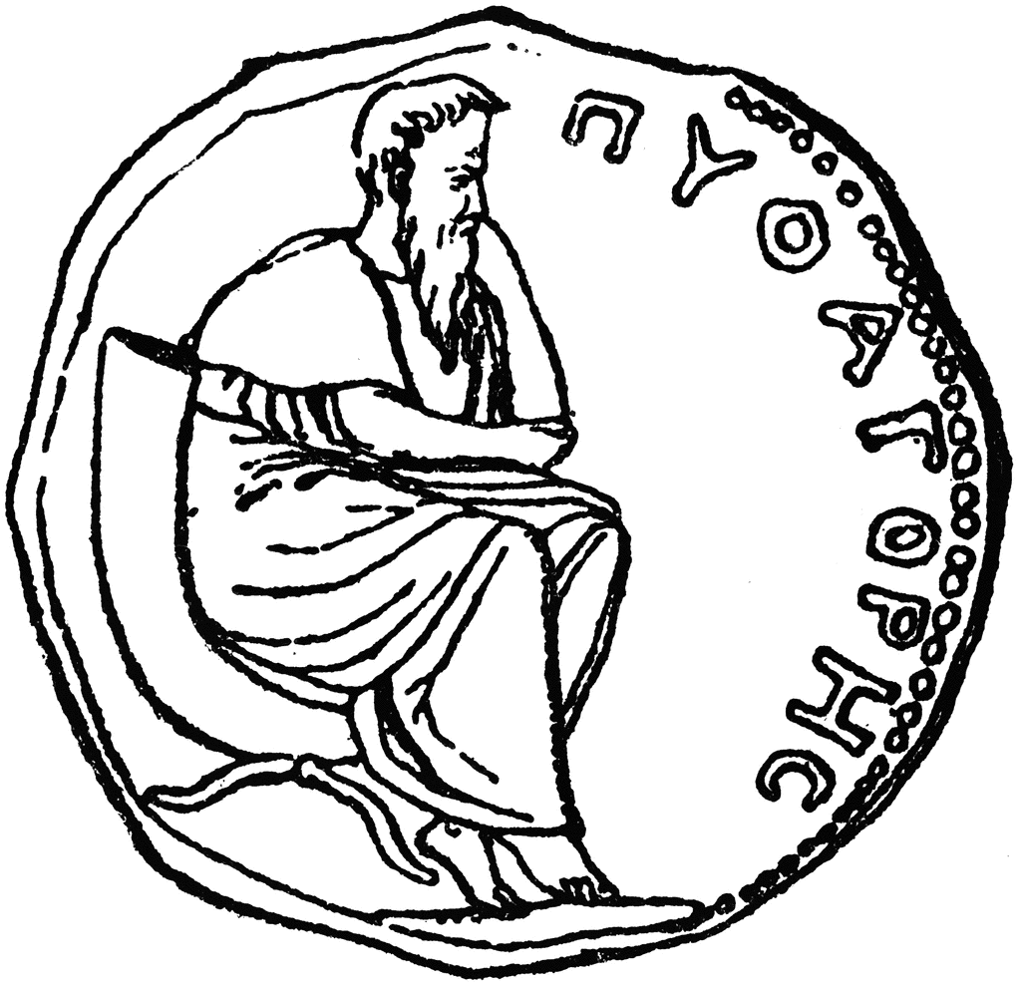
COMPUTING
I can use the internet to safely research and communicate online

I can use Microsoft Word to publish my work
PE- MONDAY AND FRIDAY
FUNCTIONAL MOVEMENT: GYMNASTICS AND DANCE
I can develop flexibility, strength, technique, control & balance through gymnastics
I can perform dances using varied movement patterns
I can participate in and enjoy Ancient Greek Olympic Sports
MUSIC
I can use my voice expressively- singing songs and speaking chants and rhymes
I can play tuned and untuned instruments musically
I can experiment with, create, select and combine sounds using the inter-related dimensions of music
I can listen with concentration and understanding to a range of high-quality live and recorded music

MATHS
PLACE VALUE
ADDITION AND SUBTRACTION
MONEY
MULTIPLICATION

ENGLISH
I can write my own greek myth
I can write rich descriptions of mythical creatures using expanded noun phrases
I can write a villain’s diary in the past tense
I can write a non-chronological report
I can use co-ordinating and subordinating conjunctions
I can plan using the story mountain format
I can edit my own work to ensure accurate spelling, punctuation and grammar
I can develop a fluid and joined handwriting style

Reading
I can make predictions from the text
I can discuss words and phrases that capture the reader’s interest and imagination
I can suggest character’s viewpoints from inferences made from the text

Oracy
I can retell events in my own stories
I can offer advice politely but informatively

Phonics/Spelling
I can read and write graphemes
from the phonics phases four and five
I can spell the Year 2 Common Exception words
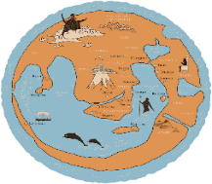
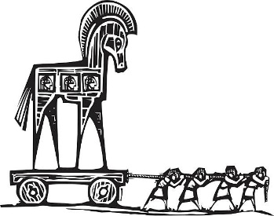
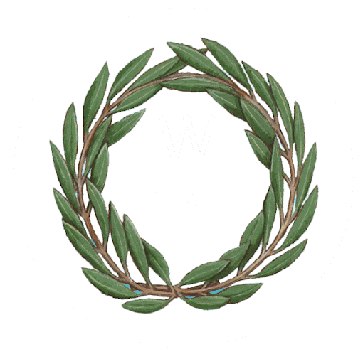
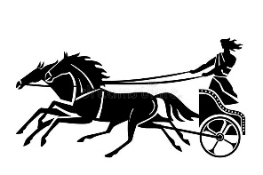
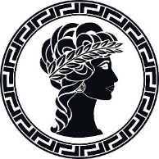
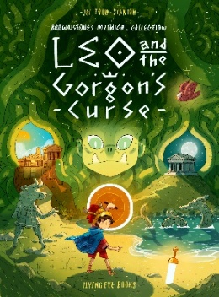

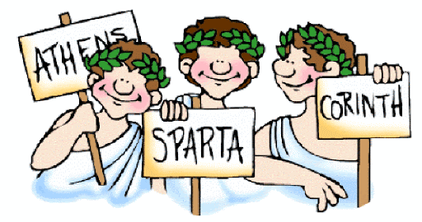
RE
I can explore the story of Jonah
I can identify what the story of Jonah teaches Christians about God
I can look for clues about God in Christian songs
I can create an artistic response to how Christians see God
PSHE
I can identify what constitutes, and how to maintain, a healthy physical and emotional lifestyle
I can describe good and bad feelings and learn how to manage my feelings
I can reflect and celebrate my strengths and set simple but challenging goals

SCIENCE
I can identify the forces acting on objects.
I can investigate how a toy car moves over different surfaces.
I can investigate how a toy car moves over different surfaces.
I can investigate the strength of magnets
HISTORY
I can observe small details from artefacts and pictures
I can sequence key events and artefacts
I can find out about the everyday lives of people and compare with our lives today
I can identify different ways the past is represented by comparing sources
I can communicate knowledge

GEOGRAPHY
I can locate and relate continent, country, county and cities of Ancient Greece to modern Greece and Semley
I can show awareness of the physical and human characteristics of a European region

ART AND DESIGN
I can study Ancient Greek sculptors and architects
I can develop my mastery of sculpture by creating a Modroc Melpomene and Thalia mask, a clay pinch pot and a soap sculpture of a horse.

DESIGN AND TECHNOLOGY
I can explore & use mechanisms
and design an-Ancient Greek chariot

GRAND DESIGNS
DOVES
AUTUMN 2021

