

Handbook
Semley
Forest School


Contents Page
Page 3 What is Forest School and Benefits of Forest School
Page 4 Our Vision
Page 5 Safety Overview
Page 6 How our sessions will run
Page 7 Examples of activities in Forest School
Page 8 How to keep safe at Forest School
Page 9 Poster of Forest School Rules
Page 10 Responsibilities
Page 11 Safe Guarding and Child Protection and Special Educational Needs
Page 12 Site Management and Site Safety
Page 13 Role of the Adults
Page 14 Communication
Page 15 Risk Assessments and Risk Management
Page 16 Fire Safety
Page 17 Tool Use
Page 18 First Aid
Page 19 Food Hygiene
Page 20 Equality and Inclusion
Page 21 Behaviours
Page 22 Equipment
Page 23 First aid kits
Page 24 Clothing Required for Forest School
Page 25 Parental Consent and Photography Consent
Page 26 Cancellation
Page 27 General Risk Benefit Assessment

What is Forest School?
Forest School is defined by the Forest Schools Association as;
‘Forest School is a long-term process of regular sessions that take place in a natural environment, promotes the holistic development of those involved, fostering resilience, confidence, independent and creative learners. It offers children the opportunity to take risk and is run by qualified Forest School practitioners, and it uses a range of learning-centered process. The adults carefully scaffold learning and provide opportunities for the child to take their learning to the next level’.
More information can be found on www.forestschoolassociation.org
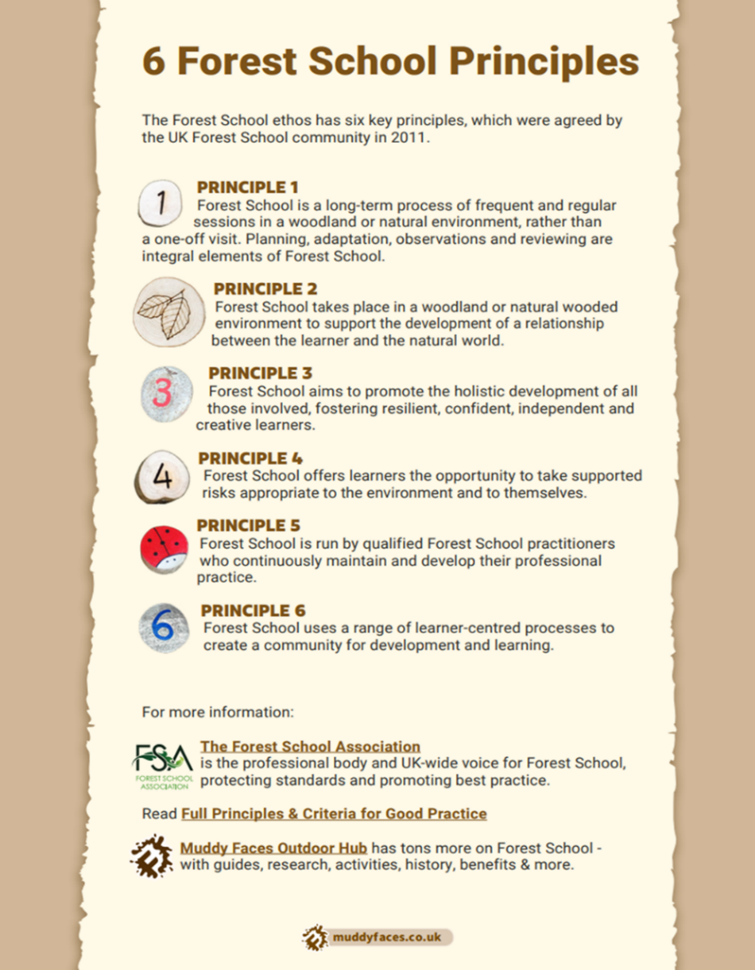

Benefits of Forest School
- Support the social and emotional development of children through play in a natural, outdoor environment
- Promoted and encourage learning through all learning styles
- Support the physical and mental development of children through active games,
tasks and problem-solving activities
- To build self-confidence and self-esteem in children and young people
- Nurture individual interests and knowledge
- To give children and young people the skills and tools to succeed and be happy
- Develop the whole child
- Encourage risk management strategies and consideration of the impact of their actions

Our vision

At Semley CE VA Primary School (Semley School), our aim is to build up our children’s emotional intelligence, resilience, self-esteem and confidence through Forest School. We strive to inspire children to have a sense of belonging to our community, develop a deeper level of self-worth and a love for learning. Our ambition is for them to take this into all areas of their lives, building up life skills and happiness. Forest School will encompass the different seasons thus helping children develop an understanding of nature and the environment.

Safety overview

Before each session, the Forest School Leader (FSL) will;
- Conduct a thorough sweep of the areas being used; the field, the fire circle, the area behind the Astro, the playground, to check for any animal waste, any litter etc. Anything found will be picked up and disposed of following the school’s waste policy – to be put into a black bin bag and then in the large outside wheelie bin in the car park
- A written record will be kept of the sweep in the purple risk assessment folder to be kept in the school office
- Weather conditions will be checked before the session and if winds of more than 30 miles per hour are present/will be forecast then the Forest School session will take place in the school hall. Other weather conditions such as extreme temperatures will be dealt with as to how the school has managed them during the day. Hot/cold drinks, appropriate clothing and shade/shelter will also be provided
- Hot weather – correct clothing worn – light t-shirts and trousers, activities to be set up in shade, shelter provided, all children to wear suncream (to be applied by themselves or come to school with a whole day cream on) and hats, water bottles to be on hand for children to help themselves throughout the sessions, water cups provided for those who don’t have a water bottle, cold squash to be provided at end of the session,
- Cold weather – children asked to wear layers, thermals, gloves (see tool policy about not wearing glove on helping hand when using tools), warm socks, shelter provided, possibly fire to keep warm, games to warm up
- Fences, tree, hedges, fire circle stumps etc will be check for any breaks, holes or other potentially dangerous hazards

How Sessions will Run
- The leader will meet the children in their classrooms and register as normal. A paper copy will be taken by the Forest School helper/ trained Forest School Assistant, they will note number of children and any absences – record to go with the FSL. Head count will be taken in classroom before we leave and when we get to FS
- We will have a bathroom break before all children put on waterproof, hats, gloves, suncream etc. They will carry their wellies to the door and wait for everyone to be ready
- Wellies will be put on outside to protect our class carpets
- The children will follow the leader to the base camp area, where we will sit around the fire circle and answer the register one more time, checking all have arrived
- We will welcome ourselves and others to FS and have a few deep breaths and ground ourselves. If any immediate safety rules and/or considerations that need to be address they will then be shared with the group then
- We will start with a listen activity, such as a check in, mindfulness activity, feeling share and/or a sit spot
- Children will be introduced to the activities of the day, these will be discussed and the safety considerations will be shared, these include independent activities and adult supported learning
- Free flow and child-led learning will now take place – Forest School Rangers to choose who goes first
- Children are taught to stop when the Forest School call is made (a wolf howl – children then repeat it back). Children will be given a suitable amount of time and then when the Forest School call is made, the children will stop, listen and follow the instructions. These will include tidy/ pack away and come together in the fire circle or choose their last activity/a ‘ten minutes to finishing’ warning to give them chance to finish activities
- Once it is tidy up time, all tools to be counted back into the box and padlocked up. All equipment to be put into the boxes ready for children and adults to carry back to class/to be put away in the shed. Resources to be put on the going home pallets
- Children will make sure area is secure, safe and respected – Play Secret Squirrels
- We will then come together to share our learning and discoveries over a drink and sometimes a snack – permission for children to have food and drinks will be on their permission forms as normal. Any dietary considerations will be accounted for (e.g. parents to provide alternatives if necessary)
- Children will share where they want to take their learning next
- A closing ceremony will take place and the fire, if lit, will be extinguished safely by the FSL using a circular motion of water from the red fire bucket
- Children and adults will then line up behind the cone and will be counted to ensure all are accounted for
- We will then walk back to the school. Once there, we will take our wellies and waterproofs off. If they are fairly clean and dry, we will carry them through the school. If they are very mucky, we will leave them outside and get our plastic bags to put them in

Example of types of activities that may take place at Forest School

A range of activities will be provided: Under close adult supervision*

- Campfire building and lighting*  - Making hot food and drinks on the campfire*  - Bush craft – working with Forest School tools*  - Den/ shelter building  - Other Bush craft activities  - Nature and wildlife discovery, observation and appreciation  - Nature and wildlife identification  - Learning about code of conduct and respect for the countryside  - Problem solving activities  - Physical challenges e.g. obstacle courses | - Teambuilding activities  - Child initiated play  - Nature Art and Craft work  - Music making  - Campfire singing  - Campfire storytelling  - Project work  - All activities aim to support the children’s social and emotional development which in turn can help raise their confidence and self-esteem.

How to keep safe at Forest School
The Forest School Leader (FSL) will conduct a thorough risk/benefit assessment for each area of FS.
Please see Appendix for all Risk Assessments
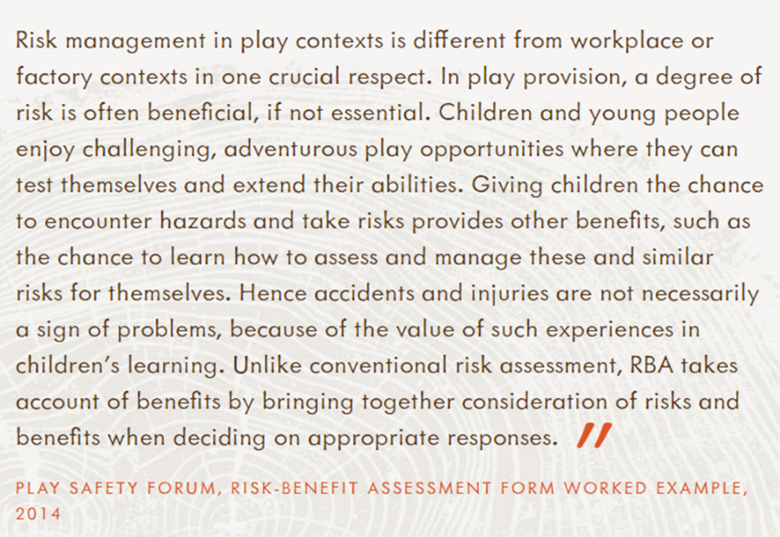

www.muddyfaces.co.uk

The children are encouraged to follow the rules for the safety of themselves, others and the natural environment we are using. Our Forest School rules will be set out by the children and the Forest School leader together following our school’s Behavior Policy. Specific to Forest School;
- Look after our natural environment in the school
- Do not pick anything growing unless the FSL says it is ok for example flowers can be picked for an activity if there are more than 10 and in the correct way to encourage regrowth
- Keep fingers away from your mouth and do not put anything in your mouths to hold, taste etc
- Follow the ‘No pick, No lick’ idea
- Stay within our school grounds or with an adult, if we are heading out of our grounds
- See Forest School Rules poster in on next page

Semley’s Forest School Rules


1. Walk around site

2. Listen Stop when you hear the call.  

3. No lick, no pick Keep your hands away from your face.  
4. Respect the fire circle - Tool use and the fire

5. Stay within school boundaries 

Responsibilities

The Forest School Leader is responsible for:
- Writing risk assessments (risk/benefit assessments) – to be signed off by the head teacher
- Safety sweep before each session and record it
- Creating planning and resources for the sessions
- Updating and informing relevant parties if matters arise
- Follow Semley School’s child protection policies and use the appropriate protocols
- Counting children to and from the sessions
- Seeing the safe release of children to the adult stated on their school forms

The Head Teacher is responsible for:
- Checking and signing off all risk assessments
- Making sure there is a Designated Safeguarding Officer on site

The Governing Body is responsible for:
- Check risk assessments

Safeguarding and Child Protection
Safeguarding at Forest School is in line with Semley CE VA Primary School’s Safeguarding policy which is available on the School’s website.
The key points are summarised below:
- Every child has the right to be kept safe from danger and learn in a safe and secure environment
- All staff involved in Forest School hold relevant DBS checks
- All volunteers will stay with the main group and Forest School leader – visitors will not be left alone or go off with any pupil. Visitor and helper guidelines to be read before the session
- All Forest School Staff attend regular Safeguarding training whether at Semley CE VA Primary School or privately sourced
- All concerns and disclosures are confidential and will only be shared with the school’s designated leaders and necessary agencies, as appropriate. How to respond to concerns/disclosure of abuse is set out in the flowcharts provided by the Safeguarding Vulnerable People Partnership (SVPP). These set out the required procedure for staff to follow. These are clearly displayed in the staffroom and adult clock rooms for easy reference
- Any disclosures will be reported to the Designated Safeguarding Lead or Deputy Designated Safeguarding Lead without delay, if these Leads are absence all staff members know to speak directly to MASH
- Semley Primary School follows the procedure set out by the SVPP ‘Allegations Against Adults’ flowchart. This is set out in the flowchart displayed in the staff room and adult clockroom for easy reference. Including low-level concerns and whistleblowing
- The Staff Behaviour Policy sets out staff behaviours that should be avoided as well as those that constitute safe practise and supports our commitment to safe guarding children. The Staff Behaviour Policy can be found on the school’s website
- The Forest School leader will hold an updated Outdoor Paediatric first aid certificate

Children with Special Educational Needs and Disabilities (SEND) or physical health issues
DSL will communicate any needs the Forest School Leader needs to know regarding individual children.

Site Management
Environmental Impact
Our Forest School in the grounds of Semley CE VA Primary School. The camp fire area is set up by the far side of the field by the fence. Children will have access to the area behind the astro pitch with activities set up there. Activities will also take place on the playground, should weather call for it. The activities will have an impact on the immediate environment and so we aim to keep this to the minimum. This will be ensured by the rotation of the use of land areas. We will take the necessary steps to amend and regulate these activities.
See Appendix 14 for our 3 Year Site Management Plan for Semley School.

Site Safety
The site is maintained by the FSL. Safety sweeps will be carried out before each session using the following format;
Date: | Time: | Weather:
Name of Forest School Leader:
Name of any helpers:

Checklist | Yes/No | Comments
Fallen branches
Low branches
Protruding thorns
Brambles/nettles
Slippery areas
Broken glass/needles
Vandalism/intruders
Weather effects
Standing water
Boundary line/fence
Base camp
Tool area roped off
Emergency rucksack
Equipment ready
Spare clothes

Other hazards identified:
Action taken:

Role of the Forest School Leader and other adults
The role of the Forest School Leader is to:
- Constantly facilitate, scaffold, monitor, assess, and guide learning for the children
- Aim to facilitate risk taking in a beneficial and safe way to promote the key Forest School ethos
- To match activities to children’s interests and to where they are presently through observation and evaluations
- Be responsible for the safety and wellbeing of the group including adults, helpers and children
- To risk assess the site, daily condition and all activities before and during the session

Role of adult helpers/other members of staff:
- To support the Forest School Leader with task such as;
- Ensure all children stay within set boundaries,
- Report back any needs immediately e.g. missing child, medical/injury needs, children who need behaviour support,
- Check and ensure children are wearing the correct clothing and footwear for the time of year and weather conditions.
- Praise children for the effort and trying new things
- Head count children before, during and after the session
- Walk children to and from the sessions
- Assist children in their exploration of activities. This is by allowing them space and time to explore and play with adult interruption/interaction only when appropriate. Making a judgement call as to whether intervening is helpful and appropriate by encouraging them to ‘be brave and have a go’. By providing equipment or resources for the next step.
- To support children’s learning and development as modelled by the Forest School Leader
- To support the children’s learning and development through answering and asking questions and responding to activity cues without ‘over influencing’ the activity
- To make sure the camp is tidy during and at the end of the sessions
- To assist children to keep safe by helping them recognise and avoid hazards such as harmful plants, germs, trip hazards etc.

Communication Methods On-site
Discussion with teachers/parents before the session
Any matters/information the Forest School leader needs to know, the teacher, teaching assistant or parent will share with the leader at an appropriate time before the session so amendments can be made.

During the session, in case of emergency or matters arising
The Forest School leader will have a walkie-talkie linked to the main office. If the office is empty the walkie-talkie will be with the person in-charge.

Children to be aware of, listen to and respond to the leader’s call
An agreed call to be used (wolf howl) and a whistle to be blow if there is an emergency.

Communication between adults on site
Adults to talk privately if any issues arise – out of ear shot of other children. Forest School leader to speak with any children about any issues.

Discussion with teachers/parents after the session
Any matters/information the Forest School leader needs to share with relevant parties will be the responsibly of the leader to share at an appropriate time after the session. If an emergency arises, the senior leader at the school will be responsible for contacting the parent/guardian.

Risk Assessment and Risk Management
A risk assessment in a school is a careful observation to identify possible risks to health and safety. Risk management is carried out to identify, manage and reduce any chance of harm caused by these risks. The significance of the harm is determined by two factors; the likelihood of something happening and the severity of harm if it does. Risk assessments are continually reviewed by stakeholders at Semley School. All risk assessments are kept in the Forest School folder that is kept in the staff room. All adults involved in the Forest School session will be informed of any considerations and the Headteacher will be informed of any significant changes to the session and if any matters need addressing before, during or after the sessions.

Ongoing dynamic Risk Assessment
The leader will constantly assess the session and respond accordingly to any changing situations.

Daily Risk Assessment
To be carried out at the site before beginning each session. If there are any changes to any risks, the appropriate controls will be put into place and the risk assessment reviewed and amended. Such consideration include;
Before the session;
- Site sweep - checking for fallen branches, debris, litter and animal waste etc.
- Weather – before the session, the weather conditions will be considered and if any changes need to be addressed.
- Tools – when tools are to be used these will be safety checked, these are always kept in a secure container with a padlock, until the qualified adult is ready to support child with their use.

During the session;
Observation - The Forest School Leader will continually ensure the group is safe and following our Forest School Rules.
Risks associated with activities – risks in activities will vary as to what the activity is. For activities with more risks, adults are there to guide and show children safe procedures. Once the adult is confident the child can follow these procedures to keep themselves safe, the adult will allow the child to use such things as the tools and fire. It is the professional judgement of the leader to ensure the children are ready and safe.

After the session site sweep;
The Forest School Leader will carry out cleaning and maintenance of tools and store them safely. They will also conduct a site sweep to ensure the Forest School area is left as it was found.

Principle 4 of the Forest School Association states; ‘Forest School offers the learner the opportunity to take supported risks appropriately to the environment and themselves’. We pride ourselves on following the Forest School ethos where children are learning to manage their own risks with guidance and care from adults if and when needed. This is called risk-benefit, where the risk is considered in relation to the benefit it has.
Please see Risk Assessments
Fire Safety

Fire Circle Rules
- We walk around the Fire Circle.
- We walk around the outside of the Fire Circle to get to the other side.
- We only enter the inner Fire Circle when instructed by the Forest School Leader.
- We tie hair up and tuck in toggles or scarves.
- Fire gauntlet gloves will be use.
- Correct handling of equipment used in cooking e.g. Storm Kettle, pop-corn maker, soaked sticks for marshmallows or metal forks

During a session using fire, careful regard and respect of the fire is reinforced throughout as a step-by-step process.

Strict fire circle rules will be enforced at all times by the Forest School Leader. Only when the children are deemed ready will a fire be had.

Before a fire is built, provision for putting out the fire is made with a red water bucket at hand, this had the word ‘Fire’ written on it. This will be kept next to the fire. There will be a separate fire first aid kit and fire safety blanket. This will be provided by Semley CE VA School and kept up to date by the Forest School leader.

The Forest School leader will assess the site for safety. They will look for overhanging branches or vegetation and make sure the floor is clear of any debris, leaf litter, sticks etc.

The fire will never be left unattended and the Forest School Leader will ensure the fire is out and cold, using lots of water using the correct method to be the fire out e.g. letting the embers burn down, a circular method starting slowly from the outside going inward, stir with a stick and repeat until the water in the fire is cool.

If the weather is hot, the Forest School Leader will assess whether it is safe to have a fire, that will be assessed on the day. The considerations will include the possibility of wind blowing embers and igniting other areas of woodland and the temperature being too hot.

Tool Use

The Forest School principles encourages one to build on skills in small steps, once the children and leaders have developed a trust and the children have shown they are ready, the leader will introduce more advanced skills such as tool use and fire with close supervision.

Tools available for use are:
Hammers, palm drills, peelers, bowsaw, folding saw, secateurs, loppers and sheath knives

- All tools are cleaned, maintained and stored securely by the Forest School Leader
- Tools are kept in padlocked tool boxes in the storage room at Semley School
- Prior to use, the Forest School Leader will check the tools for any damage or instability and check for sharpness
- Tools are transported to Forest School in a secure, labelled, padlocked box to be kept in a secure place in school
- Only the Forest School Leader’s tools can be used at Forest School, none from a visitor
- How to use all tools will be demonstrated on a group basis and then assessed on a 1:1 basis
- Only the Forest School leader will decide if the age group/individual child us ready for a particular tool by assessing for competence on a 1:1 basis
- As part of the process for assessing competence, children must be able to learn the ‘tool-talks’ and safety instructions before being considered capable of using any particular tool

First Aid

There will be a trained outdoor first aider on site at Semley CE VA Primary School during the Forest School sessions. They will be responsible for administering first aid. Forest School will follow the same protocol for first aid as that of Semley CE VA School;
- The first aider will be called and asked to assess what, if any, treatment is needed.
- They will then take the required action.
- Parents/Guardians will be notified by phone if needed, otherwise an accident slip will be written to go home with the child. This is the same accident slip used for all first aid at Semley CE VA School.
- The accident slip will be kept on the Forest School Leader’s clipboard so it can be given to the parents directly.

In the event of a serious accident, an ambulance will be called, first communication will be from the walkie-talkie. The first aider will stay with the casualty and the rest of the group will be escorted back to the hall. In the case of a serious accident involving the Forest School leader or other support staff, the other adult will use the walkie talkie to request the office to ring for an ambulance and for another member of staff to collect the children and take them to the hall.

- The qualified paediatric First Aiders are Mrs Rumney (FSL), Miss Ankers, Mrs Keeble, Mrs Caryle-Clarke and others within the school.
- The First Aid box will be kept in the FS shed. It is a green first aid kit for general treatment and a red first aid kit for a fire incident.
- The office is responsible for replenishing and ordering new supplies.
- The accident book is situated on top of the First Aid Box, and records the name of the injured person, the injury, the date and time of the accident.
- Notices stating the names of the First Aiders are located in the staff room, office and FS risk assessment folder
- Gloves to be worn by all persons who risk coming into contact with body fluids.
- Staff should be aware of the potential for allegations of improper touching of a child. If necessary, a second member of staff should be present to act as a witness. The first aider should always be in eye sight of another member of staff

Head Injuries
- ALL head injuries of any description MUST be checked and treated immediately by a qualified member of staff holding a First Aid certificate.
- If severe parents/carers will be informed immediately by phone.
- The parents/carers must be given the facts of the accident and asked if they would like to get the child or told they must get them, depending on the severity.
- A head Injury form must be completed, explaining what happened, where and when it happened, who was involved and what treatment was provided.
- When a parent collects a child from school with a head Injury, the completed form above must be given to them personally. The form is NOT to be put in a book bag or given to the child.
Food Hygiene

If and when the children are ready to prepare food and cook, several details must be followed;
- Hands must be washed on the washing station; with flowing water
- Food will be stored at the appropriate temperature before the session e.g. kept in the fridge, or ice packed thermal box or a cool cupboard/box.
- All food to be transported in a hygienic container.
- Food to be consumed sitting within our fire circle.
- No trace of food/containers/litter will be left to avoid potential animals.

FSL to hold an outdoor level 2 Food Hygiene certificate, updated every 3 years.

Equality and Inclusion

Semley CE VA Primary School promotes equal opportunities for both adults and children. As part of the Equalities Act 2010 pupils and staff/visitors/helpers are protected from discrimination.

Adaptions will be in places for any need a child or adult may have.

Further information can be found here;
Equality_Act_Advice_Final.pdf (publishing.service.gov.uk)

Behaviour
Children will be required, expected and encouraged to keep themselves as safe as they can. The adults will follow the behaviour policy of Semley CE VA Primary School.
The adults will praise and draw attention to good behaviour, the adults will model safe and positive behaviour.
Rules and expectations will be made clear at the beginning of each Forest School session and the main points recapped as and when needed.
Where appropriate, the adults will discuss any social or emotional needs of the children prior to the sessions, go over any behaviour management arrangements.
Bullying will not be tolerated.
If a child’s behaviour puts themselves or others at risk, they will be reminded of the Forest School rules. The next stage is they will be asked to stop their activity and work alongside the leader/trusted adult whom they engage best with. If the behaviour persists they will be asked to have some time out with a trusted adult/they will be removed from the session to protect themselves and their peers. If they are putting themselves or others at further risk the session will end and the children will all be escorted back to the hall.
The expectation is all children and adults will follow the rules of Forest School and act accordingly. We will also expect the children to follow the countryside code;
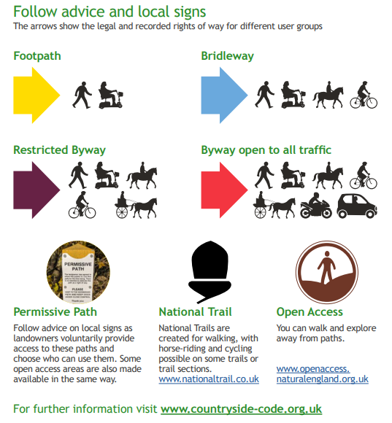

Respect everyone
Protect the Environment
Enjoy the Outdoors

Equipment and organisation
Resources and Equipment for Forest School
- Register of children when sat in the fire circle
- Medicines and list of medical needs
- Walkie Talkie
- First Aid kit (see below for breakdown of equipment in a first aid kit)
- Fire safety kit – fire bucket, fire gloves, fire blanket
- Tools in a padlocked box – 3 separate boxes, one containing palm drills, one containing peelers and knives, and the other containing hammers – including a claw hammer
- Large tools in a large padlocked bag– containing a saw, a pruning saw, a bowsaw, sheath knife,
- Storm kettle
- Fire lighting equipment – cotton wool, fire strike, tinder, dried wood
- Tarpaulins
- Rope, paracord, pegs, clips
- Games and toys
- Wood for activities
- Learning resources
- Water flasks containers with drinks and cups
- Plastic water containers for fire bucket and general water use
___________________________________________________________________________
In more detail:
Organisation
- Permission slips including tool use, food and drink consumption to be emailed out to all parents at the start of the year – it is their responsibly to contact if they do not wish their children to take part in any of the previous
- Register of children with surnames (emergency contacts held in the office)
- Medicines - container for inhalers with lid – T.A responsibility
- Medical forms – to be kept in the office, allergies e.g. hay fever, plasters, medical needs,
- Walkie Talkie – other walkie talkie to be in the office for immediate contact
- FLS – to ask questions to ensure all the of above is carried out

Children/families responsible for
- Sun cream – once a day recommended or top up before children go out – must be applied by themselves and then hands washed
- Children to come in Forest School clothes before the start of the session
- All children must use the bathroom facilitates and wash and dry their hands before we go
- Register to be taken once we get to the Forest School basecamp

Essential equipment in first aid kits
First Aid Kit containing:
- Disposable gloves
- Wound dressing
- Disposable ice packs
- Triangular bandage
- Hypoallergenic plasters
- Hand gel
- Antibacterial wipes
- Eye pad
- Scissors
- Adhesive medical tape
- Face shield
- Absorbent padding
- Tourniquet

Other essential equipment:
- Any necessary individual medication (inhalers etc)

Burns/Fire Kit containing:
- Burn dressing
- HypaTouch gloves
- Emergency burn gel
- Comforting bandage
- Cup for running water over burn – clean water to be kept in a separate container

Clothing required for Forest School

Forest School sessions will take place in all weather conditions unless the safety of children and adults is at risk. Events such as high winds (30 miles per hour) or thunder and lightning will put stop to a session.

All participants need to be in suitable clothing to stay safe and enjoy the experience. Clothing includes;

Warm/hot weather
Sun Hat
Lightweight long sleeve top
Lightweight long trousers
Wellies or stout shoes/trainers
Waterproof trousers or dungarees
Waterproof coat

N.B all day suncream is recommended and a top up can be applied by the child.
On particularly hot days, shorts and short sleeved t-shirts maybe worn at the risk of ticks, child’s adult must decide and ensure children have the correct kit

Cool/cold weather
Warm hat, gloves (to be removed if using tools), neck warmer – no scarfs as fire hazard
Long sleeve top
Long trousers
Wellies or stout shoes/trainers
Waterproof trousers or dungarees – encourage PU material
Warm and waterproof coat
Extra layers such a fleece, sweatshirt, leggings and tights.

All Forest School clothing must be named clearly.

Parental Consent and Photographic Consent (including social media)

Parental consent - it is given that all children will be able to take part in FS, parents/guardians will be invited to discuss any concerns with the FSL and Headteacher.

Photographic consent - as part of the school’s information regarding each child, parents/guardian are required to complete a form to give or decline parental consent for photographs. This permission applies to FS as well. Social media will not be used, however the website will.

Cancellation

Forest School sessions will take place in all weather conditions unless the safety of children and adults is at risk. Cancellation will occur in events such as high winds (30 miles per hour), thunder, lightning or snowfall that will restrict the children and adults getting home safely.

If such conditions arise, the Forest School Leader will make a judgement call as to whether the session will go head. It will be decided alongside DSL whether the session be moved indoors into an area such as the hall.

